12.82: The direct calculation of the force that the sphere exerts on the ring is slightly more involved than the calculation of the force that the ring exerts on the ball. These forces are equal in magnitude but opposite in direction, so it will suffice to do the latter calculation. By symmetry, the force on the sphere will be along the axis of the ring in Fig. (12.34), toward the ring. Each mass element 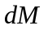of the ring exerts a force of magnitude 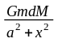 on the sphere, and the x-component of this force is
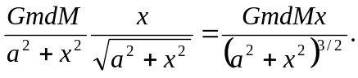

As x >> a the denominator approaches 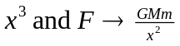, as expected, and so the force on the sphere is 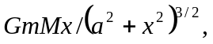 in the 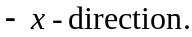The sphere attracts the ring with a force of the same magnitude. (This is an alternative but equivalent way of obtaining the result of parts (c) and (d) of Exercise 12.39.)2

